程式設計(二)

期末專題

1102065

游竣捷

**目錄**

* **程式說明 2**
  + **系統分析 3**
  + **流程圖 3**
  + **類別圖 4**
* **主要程式碼說明 5**
  + **亮度調整(HSV) 5**
* **測試 9**
  + **測試程式碼 9**
  + **執行結果 10**
* **完整程式碼 13**

**程式說明**

此程式為本學期上課內容作為延伸，原先功能已包含讀取和寫入Bitmap，

將Bitmap圖片轉換為黑白、做模糊化、二值化、使用遮罩產生描邊效果、

兩張Bitmap圖片相加做合成。

延伸功能

可自由調整Bitmap的整體亮度，如下圖所示。

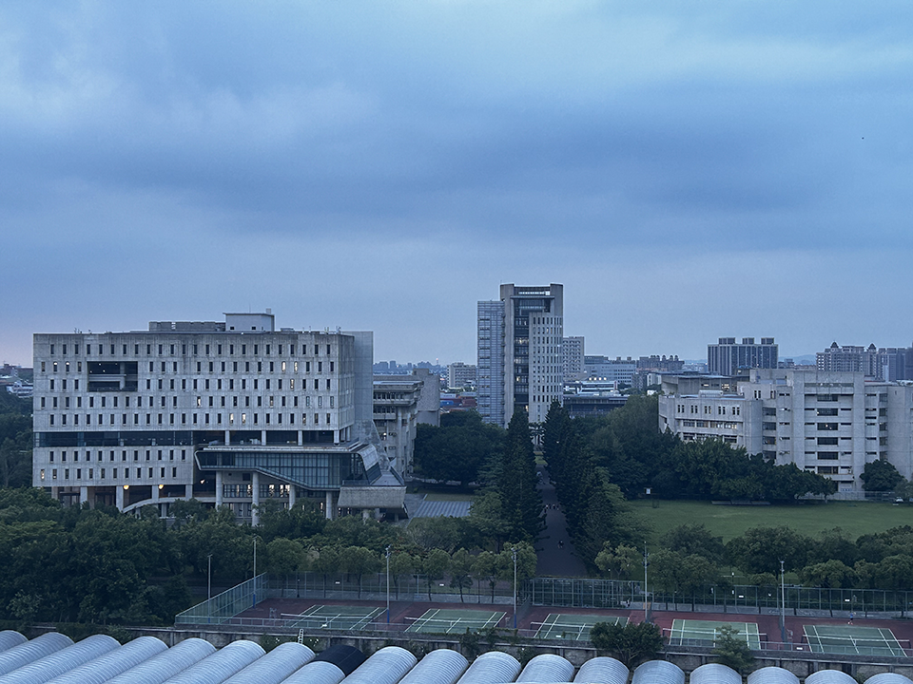

原圖

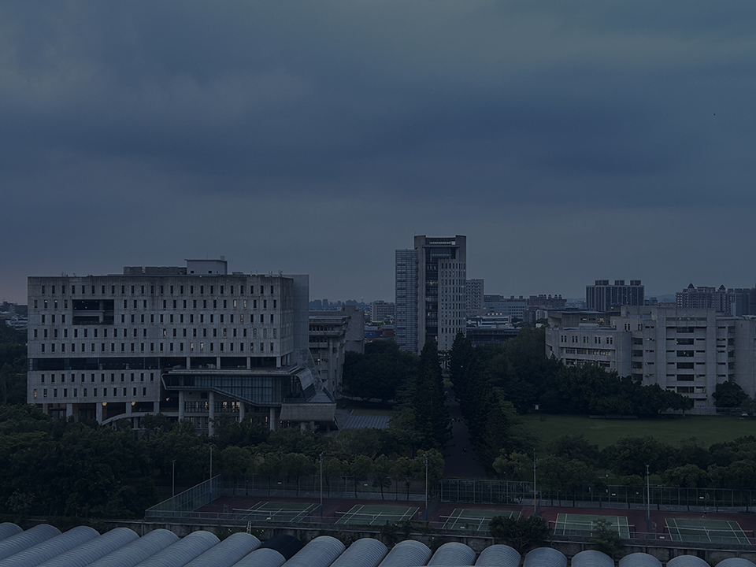

亮度調暗

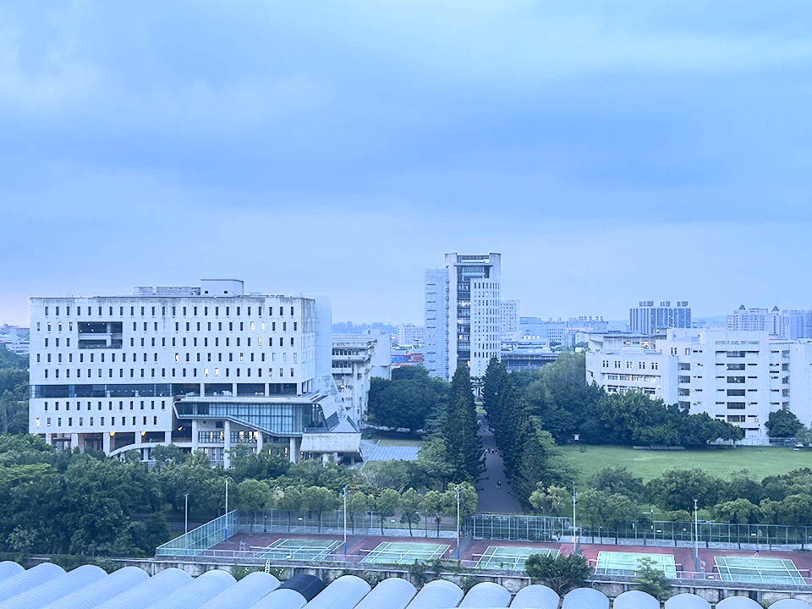

亮度調亮

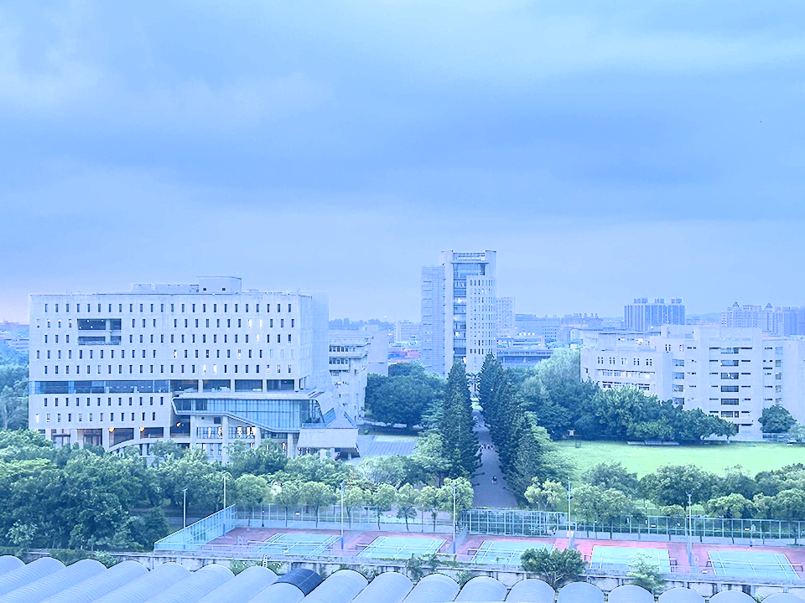

亮度更亮

**系統分析**

1. 讀取的Bitmap資料色彩空間為RGB。
2. 將Bitmap資料的每一個像素的RGB透過公式轉換為HSV。
3. 透過將每個像素的HSV的V值乘以一個倍數，調整整體圖像的亮度。
4. 將改變後的HSV數值轉換回RGB。

注意:

1. RGB範圍為0~255之間
2. H範圍為0~360之間
3. S 和 V 範圍為0~1之間

轉換公式參考自維基百科

<https://en.wikipedia.org/wiki/HSL_and_HSV>

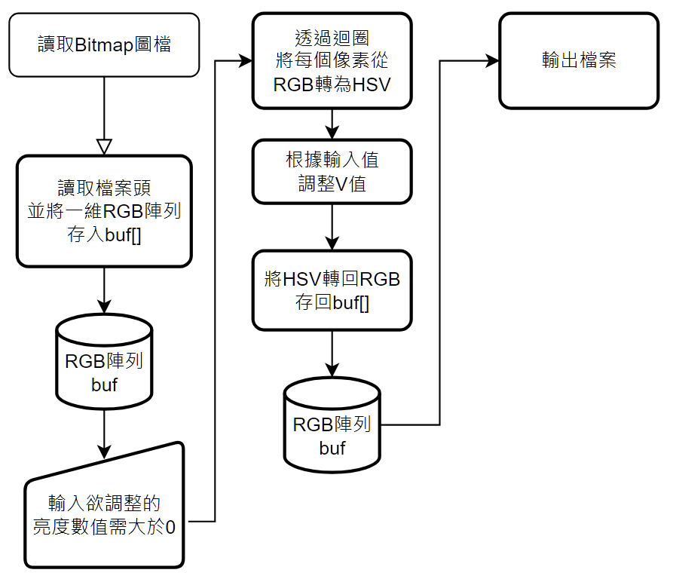**流程圖**

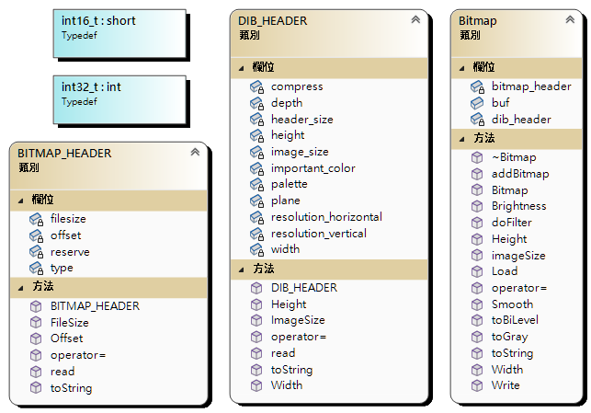**類別圖**

**主要程式碼說明**

/********************************************************************

Value needs to be a float num greater than zero,

0~1 will decrease brightness, 1~2 will increase brightness.

if Value is too bigger, the result will be brighter,

but it maybe isn't a good result.

輸入的數值為大於0的浮點數，

0 ~ 1(ex. 0.5) 會將低圖像的亮度

1 ~ 2(ex. 1.5) 會增加圖像的亮度

********************************************************************/

void Brightness(double Value) {

int rawsize = imageSize(); //Bitmap圖像RGB陣列長度

int width = Width(); //圖像寬度

int height = Height();//圖像高度

int BitsPerPixel = 24; //色彩深度

//重新計算Rowsize使其適配所有影像大小

int RowSize = ((BitsPerPixel * width + 31) / 32) * 4;

int i;

//透過迴圈讀取每一個像素點的RGB

for (int y = 0; y < height; y++)

{

for (int x = 0; x < width; x++)

{

//透過長寬計算像素點在一維陣列中的相對位置

i = y * RowSize + (x * 3) % RowSize;

// 讀取 RGB 值

// buf中的數值有可能為負數。所以資料型別使用

// unsigned char

unsigned char b = buf[i];

unsigned char g = buf[i + 1];

unsigned char r = buf[i + 2];

// RGB To HSV Formula

// 參考致維基百科公式

// 正規化 使RGB數值為 0~1 之間

// 將unsigned char 轉為 double / 255　做正規化

double R = static_cast<double>(r) / 255;

double G = static_cast<double>(g) / 255;

double B = static_cast<double>(b) / 255;

double H, S, V;

// 取得 RGB 中最大與最小的數值，並計算兩者的差值，

// 用於轉換公式

double Max = max(max(R, G), B);

double Min = min(min(R, G), B);

double Delta = Max - Min;

// Define H

if (Delta == 0) { //如果最大值與最小值相等，即差值為0

H = 0; // H = 0

}

else if (Max == R) { //如果最大值是 R，帶入相對應公式

// fmod()為浮點數取餘數的函式

H = 60 * (fmod(((G - B) / Delta), 6));

}

else if (Max == G) { //如果最大值是 G，帶入相對應公式

H = 60 * ((B - R) / Delta + 2);

}

else if (Max == B) { //如果最大值是 B，帶入相對應公式

H = 60 * ((R - G) / Delta + 4);

}

//執行過程中發現計算後的H值有可能為負的，

//而色調 H 為360度色環，因此加上360度修正。

if (H < 0) {

H += 360;

}

// Define S

if (Max == 0) { //如果最大值等於0

S = 0; //飽和度 S = 0

}

else { //否則，帶入對應的公式

S = Delta / Max;

}

// Define V

V = Max; // V值對於最大值

// END of RGB To HSV Formula

// Adjust V's Value

// 調整V的數值，須注意的是V的大小為 0~1之間

// 所以這邊使用max()、min()，讓 V*乘以輸入的數值後，

// V 的大小仍在0~1之間

V = max(0.0,min(V * Value, 1.0));

// HSV To RGB Formula

// 依照公式表計算欲轉換至RGB所需的數值

double C = V * S;

double h = fmod(H / 60, 6);

double X = C * (1 - abs(fmod(h, 2) - 1));

double m = V - C;

r = g = b = 0;

// h取完餘數後，大小為0~6之間的浮點數

// 參照公式，根據h值的不同，會有不同的RGB給值組合

// 因為之前正規化除以255，所以現在將255乘回去

if (0 <= h && h < 1) {

r = (C + m) * 255;

g = (X + m) * 255;

b = (m) * 255;

}

else if (1 <= h && h < 2) {

r = (X + m) * 255;

g = (C + m) * 255;

b = (m) * 255;

}

else if (2 <= h && h < 3) {

r = (m) * 255;

g = (C + m) * 255;

b = (X + m) * 255;

}

else if (3 <= h && h < 4) {

r = (m) * 255;

g = (X + m) * 255;

b = (C + m) * 255;

}

else if (4 <= h && h < 5) {

r = (X + m) * 255;

g = (m) * 255;

b = (C + m) * 255;

}

else if (5 <= h && h < 6) {

r = (C + m) * 255;

g = (m) * 255;

b = (X + m) * 255;

}

// END of HSV To RGB Formula

// Store RGB to buf[]

//將HSV轉換至RGB的值存至 buf[] 中

buf[i] = b;

buf[i + 1] = g;

buf[i + 2] = r;

}

}

}

**測試**

**測試程式碼**

void make_dir(const string dir_name)

{

if (_access(dir_name.c_str(), 0) == -1)//如果路徑不存在，無法存取

int re = _mkdir(dir_name.c_str());//建立資料夾

}

void BrightTest() {

Bitmap bmp, bmp2, bmp3, bmp4, bmp5;

string path = "BrightTest";

make_dir(path); //如果路徑不存在，建立資料夾

bmp.Load("campus.bmp"); //讀檔

bmp2 = bmp3 = bmp4 = bmp5 = bmp;

bmp.Brightness(0.2); //數值0.2，亮度變非常暗

bmp.Write(path + "/result1.bmp");

bmp2.Brightness(0.5); //數值0.5，亮度變暗

bmp2.Write(path + "/result2.bmp");

bmp3.Brightness(1.5); //數值1.5，亮度變亮

bmp3.Write(path + "/result3.bmp");

bmp4.Brightness(2.5); //數值2.5，亮度變很亮

bmp4.Write(path + "/result4.bmp");

bmp5.Brightness(4); //數值4，亮度變非常亮

bmp5.Write(path + "/result5.bmp");

}

**執行結果**

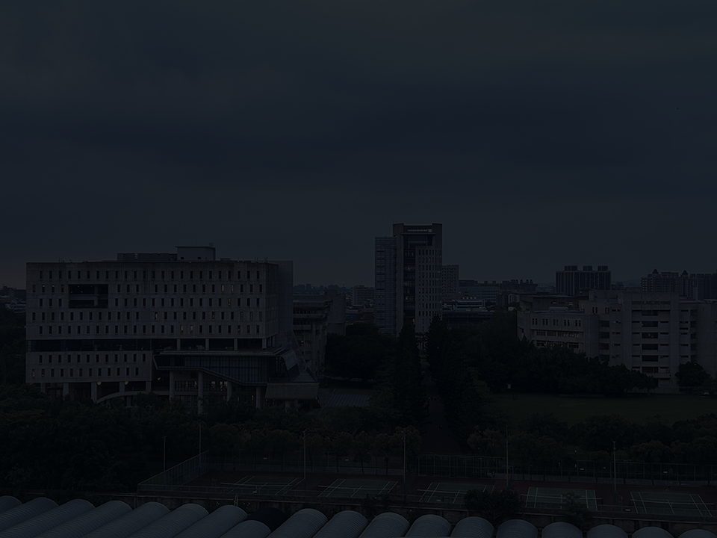

圖(二)調整數值0.2



圖(一)原圖

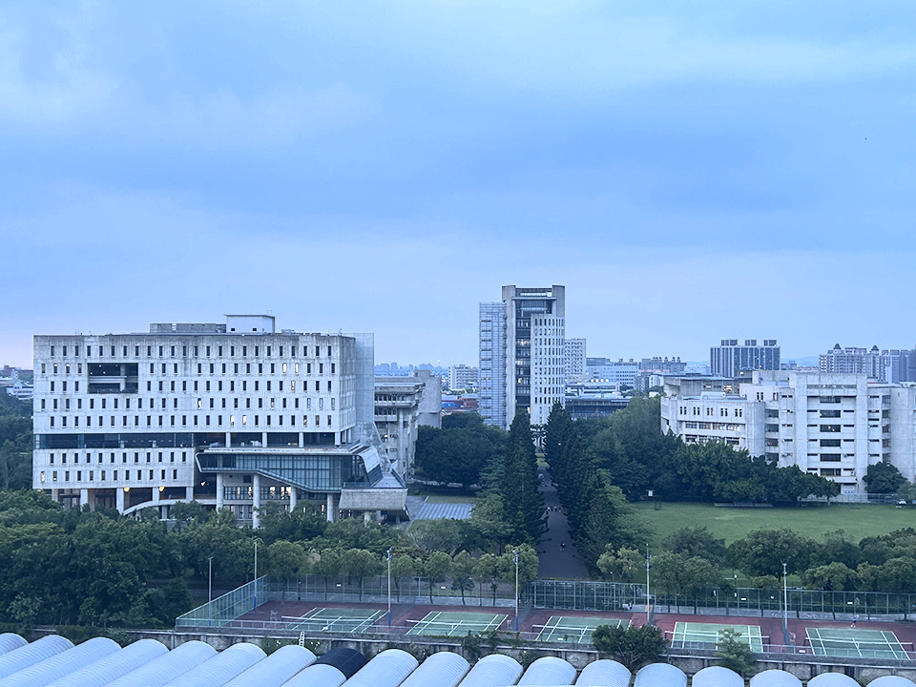

圖(四)調整數值1.5



圖(三)調整數值0.5

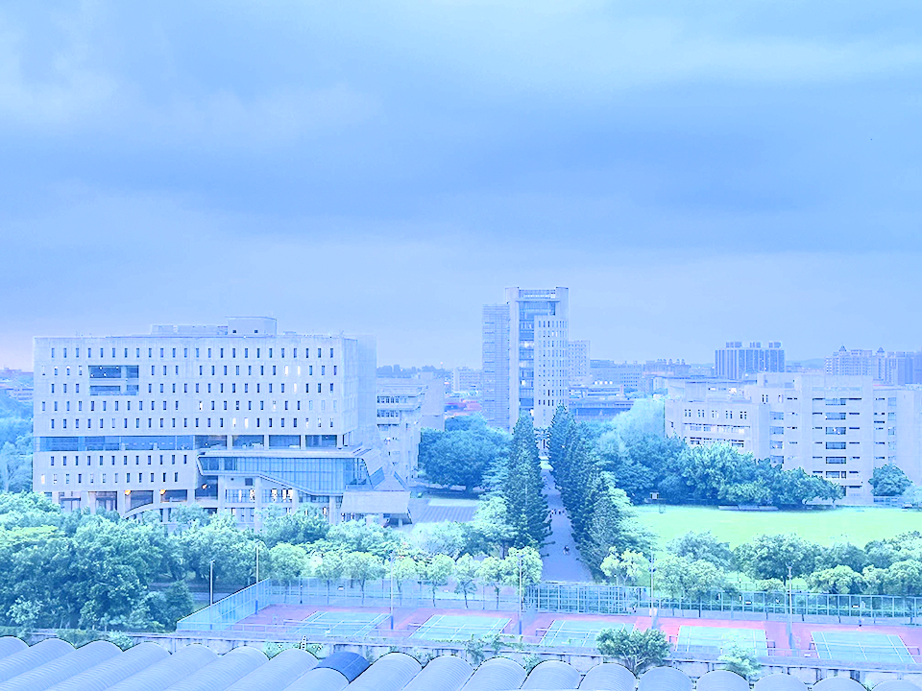

圖(六) 調整數值4

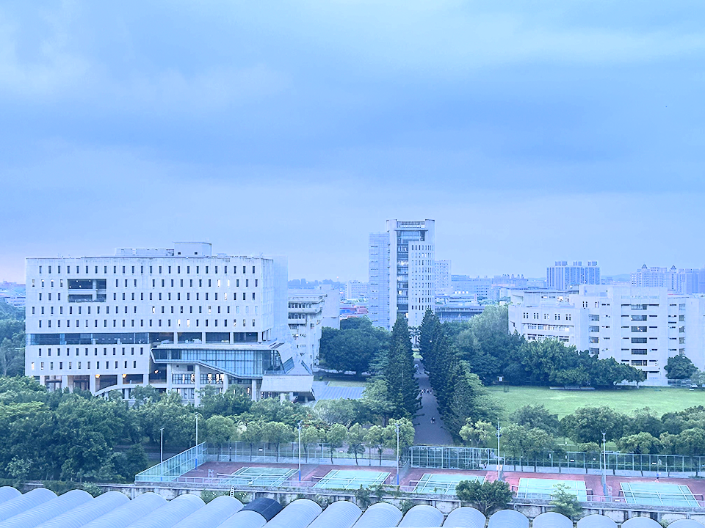

圖(五) 調整數值2.5

**完整程式碼**

#include <iostream>

#include <fstream>

#include <string>

#include <sstream>

#include <io.h>

#include <direct.h>

using namespace std;

typedef int int32_t;

typedef short int16_t;

#pragma pack(push)

#pragma pack(1)//

class BITMAP_HEADER {

private:

char type[2];

int filesize;

int reserve;

int offset;

public:

BITMAP_HEADER() {

type[0] = 0;

type[1] = 0;

filesize = 0;

reserve = 0;

offset = 0;

}

void read(ifstream& is) {

is.read((char*)(this), sizeof(BITMAP_HEADER));

}

string toString() {

stringstream ss;

ss << "class size: " << sizeof(BITMAP_HEADER) << endl;

ss << "type: " << type[0] << type[1] << endl;

ss << "file size: " << filesize << endl;

ss << "offset: " << offset << endl;

return ss.str();

}

const int FileSize() const {

return filesize;

}

const int Offset() const {

return offset;

}

BITMAP_HEADER& operator=(const BITMAP_HEADER& other) {

this->type[0] = other.type[0];

this->type[1] = other.type[1];

this->filesize = other.filesize;

this->reserve = other.reserve;

this->offset = other.offset;

return *this;

}

};

class DIB_HEADER {

private:

int header_size;

int width;

int height;

short plane;

short depth;

int compress;

int image_size;

int resolution_horizontal;

int resolution_vertical;

int palette;

int important_color;

public:

DIB_HEADER() {

header_size = 0;

width = 0;

height = 0;

plane = 0;

depth = 0;

compress = 0;

image_size = 0;

resolution_horizontal = 0;

resolution_vertical = 0;

palette = 0;

important_color = 0;

}

void read(ifstream& is) {

is.read(reinterpret_cast<char*>(this), sizeof(DIB_HEADER));

}

string toString() {

stringstream ss;

ss << "header size: " << header_size << endl;

ss << "width: " << width << endl;

ss << "height:" << height << endl;

ss << "plane: " << plane << endl;

ss << "depth: " << depth << endl;

ss << "compresion: " << compress << endl;

ss << "image size: " << image_size << endl;

ss << "horizontal resolution: " << resolution_horizontal << endl;

ss << "vertical resolution: " << resolution_vertical << endl;

ss << "palette: " << palette << endl;

ss << "important color: " << important_color << endl;

return ss.str();

}

int Width() {

return width;

}

int Height() {

return height;

}

int ImageSize() {

return image_size;

}

DIB_HEADER& operator=(const DIB_HEADER& other) {

this->header_size = other.header_size;

this->width = other.width;

this->height = other.height;

this->plane = other.plane;

this->depth = other.depth;

this->compress = other.compress;

this->image_size = other.image_size;

this->resolution_horizontal = other.resolution_horizontal;

this->resolution_vertical = other.resolution_vertical;

this->palette = other.palette;

this->important_color = other.important_color;

return *this;

}

};

class Bitmap

{

private:

BITMAP_HEADER bitmap_header;

DIB_HEADER dib_header;

public:

char* buf;

Bitmap() { buf = NULL; }

~Bitmap() { if (buf) delete[] buf; }

void Load(string filename)

{

ifstream file;

file.open(filename, fstream::binary);

bitmap_header.read(file);

dib_header.read(file);

int rawsize = dib_header.ImageSize();

buf = new char[rawsize];

file.read(buf, rawsize);

file.close();

}

void Write(string filename)

{

ofstream outfile;

outfile.open(filename, fstream::binary);

outfile.write((char*)(&bitmap_header), sizeof(bitmap_header));

outfile.write((char*)(&dib_header), sizeof(dib_header));

int rawsize = dib_header.ImageSize();

outfile.write(buf, rawsize);

outfile.close();

}

string toString()

{

stringstream ss;

ss << "[bitmap header]" << endl;

ss << bitmap_header.toString();

ss << "[dib header]" << endl;

ss << dib_header.toString();

return ss.str();

}

int Width()

{

return dib_header.Width();

}

int Height()

{

return dib_header.Height();

}

int imageSize()

{

return dib_header.ImageSize();

}

void Smooth()

{

double M[3][3] = { {1. / 9.,1. / 9., 1. / 9.} ,

{1. / 9.,1. / 9., 1. / 9.} ,

{1. / 9.,1. / 9., 1. / 9.} };

doFilter(M);

}

void toGray()

{

int rawsize = imageSize();

int width = Width();

int height = Height();

int gray = 0;

unsigned char R = 0, G = 0, B = 0;

int BitsPerPixel = 24;

int RowSize = ((BitsPerPixel * width + 31) / 32) * 4;

int i;

for (int y = 0; y < height; y++)

{

for (int x = 0; x < width; x++)

{

i = y * RowSize + (x * 3) % RowSize;

B = buf[i];

G = buf[i + 1];

R = buf[i + 2];

gray = int(0.299 * R + 0.587 * G + 0.114 * B);

if (gray > 255) gray = 255;

if (gray < 0) gray = 0;

buf[i] = buf[i + 1] = buf[i + 2] = gray;

}

}

}

void toBiLevel(int threshold)

{

int rawsize = imageSize();

int width = Width();

int height = Height();

int gray = 0;

unsigned char R = 0, G = 0, B = 0;

int BitsPerPixel = 24;

int RowSize = ((BitsPerPixel * width + 31) / 32) * 4;

int i;

for (int y = 0; y < height; y++)

{

for (int x = 0; x < width; x++)

{

i = y * RowSize + (x * 3) % RowSize;

B = buf[i];

G = buf[i + 1];

R = buf[i + 2];

gray = int(0.299 * R + 0.587 * G + 0.114 * B);

if (gray > threshold) gray = 255;

else gray = 0;

buf[i] = buf[i + 1] = buf[i + 2] = gray;

}

}

}

void doFilter(double M[][3])

{

int rawsize = imageSize();

int width = Width();

int height = Height();

unsigned char gray = 0;

int BitsPerPixel = 24;

int RowSize = ((BitsPerPixel * width + 31) / 32) * 4;

int i;

unsigned char** A;

A = new unsigned char* [height];

for (i = 0; i < height; i++)

A[i] = new unsigned char[width];

for (int y = 0; y < height; y++)

for (int x = 0; x < width; x++)

{

i = y * RowSize + (x * 3) % RowSize;

A[y][x] = buf[i];

}

int m, n;

for (int y = 1; y < height - 1; y++)

{

for (int x = 1; x < width - 1; x++)

{

i = y * RowSize + (x * 3) % RowSize;

gray = 0;

for (m = 0; m < 3; m++)

for (n = 0; n < 3; n++)

gray += A[y + m - 1][x + n - 1] * M[m][n];

buf[i] = buf[i + 1] = buf[i + 2] = gray;

if (gray > 255) gray = 255;

if (gray < 0) gray = 0;

}

}

}

void addBitmap(const Bitmap& other, double opacity, double other_opcity) {

int rawsize = imageSize();

int width = Width();

int height = Height();

unsigned char gray = 0;

unsigned char R = 0, G = 0, B = 0;

unsigned char other_R = 0, other_G = 0, other_B = 0;

int BitsPerPixel = 24;

int RowSize = ((BitsPerPixel * width + 31) / 32) * 4;

int i;

for (int y = 0; y < height; y++)

{

for (int x = 0; x < width; x++)

{

i = y * RowSize + (x * 3) % RowSize;

B = buf[i];

G = buf[i + 1];

R = buf[i + 2];

double r, g, b, other_r, other_g, other_b;

r = static_cast<double>(R);

g = static_cast<double>(G);

b = static_cast<double>(B);

other_B = other.buf[i];

other_G = other.buf[i + 1];

other_R = other.buf[i + 2];

other_r = static_cast<double>(other_R);

other_g = static_cast<double>(other_G);

other_b = static_cast<double>(other_B);

R = r * opacity + other_r * other_opcity;

G = g * opacity + other_g * other_opcity;

B = b * opacity + other_b * other_opcity;

buf[i] = B;

buf[i + 1] = G;

buf[i + 2] = R;

}

}

}

/****************************************************************

Value need to be a float num greater than zero,

0~1 is decrease brightness, 1~2 is increase brightness

if Value is more bigger, the result will be brighter but it

maybe isn't a good result.

****************************************************************/

void Brightness(double Value) {

int rawsize = imageSize();

int width = Width();

int height = Height();

int BitsPerPixel = 24;

int RowSize = ((BitsPerPixel * width + 31) / 32) * 4;

int i;

for (int y = 0; y < height; y++)

{

for (int x = 0; x < width; x++)

{

i = y * RowSize + (x * 3) % RowSize;

// Read RGB Value

unsigned char b = buf[i];

unsigned char g = buf[i + 1];

unsigned char r = buf[i + 2];

// Normalization let RGB's value between 0~1

double R = static_cast<double>(r) / 255;

double G = static_cast<double>(g) / 255;

double B = static_cast<double>(b) / 255;

// RGB To HSV Formula

double H, S, V;

double Max = max(max(R, G), B);

double Min = min(min(R, G), B);

double Delta = Max - Min;

if (Delta == 0) { // Define H

H = 0;

}

else if (Max == R) {

H = 60 * (fmod(((G - B) / Delta), 6));

}

else if (Max == G) {

H = 60 * ((B - R) / Delta + 2);

}

else if (Max == B) {

H = 60 * ((R - G) / Delta + 4);

}

if (H < 0) {

H += 360;

}

if (Max == 0) { // Define S

S = 0;

}

else {

S = Delta / Max;

}

V = Max; // Define V

// END of RGB To HSV Formula

// Adjust V's Value

V = max(0.0,min(V * Value, 1.0));

// HSV To RGB Formula

double C = V * S;

double h = fmod(H / 60, 6);

double X = C * (1 - abs(fmod(h, 2) - 1));

double m = V - C;

r = g = b = 0;

if (0 <= h && h < 1) {

r = (C + m) * 255;

g = (X + m) * 255;

b = (m) * 255;

}

else if (1 <= h && h < 2) {

r = (X + m) * 255;

g = (C + m) * 255;

b = (m) * 255;

}

else if (2 <= h && h < 3) {

r = (m) * 255;

g = (C + m) * 255;

b = (X + m) * 255;

}

else if (3 <= h && h < 4) {

r = (m) * 255;

g = (X + m) * 255;

b = (C + m) * 255;

}

else if (4 <= h && h < 5) {

r = (X + m) * 255;

g = (m) * 255;

b = (C + m) * 255;

}

else if (5 <= h && h < 6) {

r = (C + m) * 255;

g = (m) * 255;

b = (X + m) * 255;

}

// END of HSV To RGB Formula

// Store RGB to buf[]

buf[i] = b;

buf[i + 1] = g;

buf[i + 2] = r;

}

}

}

Bitmap& operator= (const Bitmap& other) {

this->bitmap_header = other.bitmap_header;

this->dib_header = other.dib_header;

int rawsize = imageSize();

if (this->buf == NULL) {

this->buf = new char[rawsize];

}

else {

delete[] this->buf;

this->buf = new char[rawsize];

}

for (int i = 0; i < rawsize; i++) {

this->buf[i] = other.buf[i];

}

return *this;

}

};

#pragma pack(pop)

void make_dir(const string dir_name)

{

if (_access(dir_name.c_str(), 0) == -1)

int re = _mkdir(dir_name.c_str());

}

void BitmapTest() {

double M2[3][3] = { {1,0,-1} ,{2,0,-2} ,{1,0,-1} }; //綜向

double M3[3][3] = { {1,2,1} ,{0,0,0} ,{-1,-2,-1} }; //橫向

Bitmap bmp, bmp2, bmp3, bmp4, bmp5;

string path = "BitmapTest";

make_dir(path);

bmp.Load("campus.bmp");

bmp2 = bmp;

bmp.Brightness(2);

bmp.Write(path+"/result1.bmp");

bmp2.toGray();

bmp2.Write(path + "/result2.bmp");

bmp2.Smooth();

bmp2.Write(path + "/result3.bmp");

bmp2.toBiLevel(100);

bmp2.Write(path + "/result4.bmp");

bmp2.doFilter(M2);

bmp2.Write(path + "/result5.bmp");

bmp2.addBitmap(bmp, 0.5, 0.5);

bmp2.Write(path + "/result6.bmp");

}

void BrightTest() {

Bitmap bmp, bmp2, bmp3, bmp4, bmp5;

string path = "BrightTest";

make_dir(path);

bmp.Load("campus.bmp");

bmp2 = bmp3 = bmp4 = bmp5 = bmp;

bmp.Brightness(0.2);

bmp.Write(path + "/result1.bmp");

bmp2.Brightness(0.5);

bmp2.Write(path + "/result2.bmp");

bmp3.Brightness(1.5);

bmp3.Write(path + "/result3.bmp");

bmp4.Brightness(2.5);

bmp4.Write(path + "/result4.bmp");

bmp5.Brightness(4);

bmp5.Write(path + "/result5.bmp");

}

int main(int argc, char** argv) {

BrightTest();

BitmapTest();

return 0;

}